# Objective: Recover the Tolkien Ring

After talking to Santa on the North Pole to get your objectives, find the entrance to the underground caverns the elves and sporcs (!) have carved. Then find your way to the Tolkien Ring.

## Wireshark Practice

Click the Wireshark Phishing terminal next to Sparkle Redberry to get started with this challenge. Basic networking skills and knowledge of what can be found in packet captures are essential for cyber security

The suspicious pcap you will analyze is available in the link in the objective, or in the PCAP link that Sparkle talks about. Here is the link: <https://storage.googleapis.com/hhc22_player_assets/suspicious.pcap>

Remember to type hint in the top panel of the terminal if you need help. When you complete the terminal, it will automatically exit and give you credit for the objective on your badge.

### Answers to Wireshark Practice

#### Question 1

Files can be extracted from captures, and Wireshark can grab some types of objects for you automatically. Only one type exists in this pcap (you can try them all to prove this.) The answer is HTTP

#### Question 2

Export-Objects -> HTTP gives you this. The answer is app.php

#### Question 3

The last, largest, app.php file starts at packet 687, and that is the one they want.

#### Question 4

The server is the one that responds to the requests sent by the client. If you are not sure, look at the [three-way handshake](https://www.techopedia.com/definition/10339/three-way-handshake). The client sends the SYN, and the server sends the SYN/ACK. 192.185.57.242

#### Question 5

This requires more digging. If you use, Follow -> HTTP Stream on the GET /app.php packet you will see the contents of app.php. (Note: click on a packet with HTTP in the protocol column so that HTTP stream is available on the Follow -> menu. If you Follow -> TCP stream, Wireshark will not expand the GZIP in the response, and you will see gibberish.) Or you can save app.php as a file from the HTTP object list, above. At any rate, after the beginning shown here you see a giant block of what appears to be base64 encoded data. This is the malware file. After the base64 you can see the code where the file is decoded and saved. The answer for the objective is Ref_Sept24-2020.zip

#### Question 6

I can seldom find the display filter I need by downloading big lists of filters. Instead, I find what I want in a packet.

Right click on the certificate line in the packet body. Select Prepare as filter -> selected.  
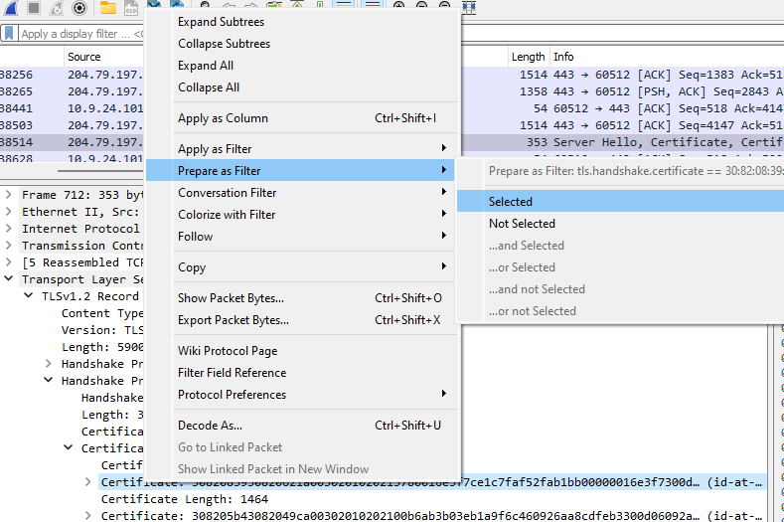

A display filter magically appears.

Get rid of all the hex stuff because we want to find all certificates, not just a specific one. Now we have nothing but certificates.

Here is what it looks like when you click through the certificate tree to find the country.

With Wireshark, you must click through every certificate to find the country code. You can export the certificates If you wish to validate whether a certificate is valid or not, using [this method](https://community.fortinet.com/t5/FortiGate/Technical-Tip-How-to-extract-a-certificate-from-a-Wireshark/ta-p/189764). However, the challenge will accept countries with good certs as well as bad if all the bad ones are included. Note that Wireshark is giving country codes and the challenge wants full names. You can [look up the names here](https://www.ssl.com/country-codes/).

The bad ones were Israel, South Sudan. You could also have Ireland and United States in the mix and get credit.

If you like tshark, you can get all the countries very quickly with this from PowerShell,  
&'C:\Program Files\Wireshark\tshark.exe' -r .\suspicious.pcap -Y 'tls.handshake.certificate' -T fields -e 'x509sat.CountryName'

Or this from Linux:

We’ll work more with tshark in Web Ring later.

## Windows Event Logs

If you work in digital forensics, incident response, threat hunting, or even a SOC, you need to be able to extract information from Windows event logs.

<https://storage.googleapis.com/hhc22_player_assets/powershell.evtx>

Be sure to watch this talk. It gives you valuable information you will need for the challenge.  
<http://www.youtube.com/watch?v=5NZeHYPMXAE>  
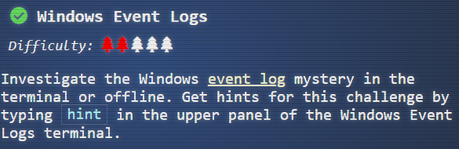  
<https://storage.googleapis.com/hhc22_player_assets/powershell.evtx>

Both Dusty’s discussion and the objective give you a link to the event log you will need.

Pay careful attention to the Event ID that Eric uses in the talk. It will save time for you.

**Your goal is to extract all the commands that were executed. Then you will have what you need to answer the questions**.

If you like Linux, the logs are in the terminal in text format, and you can do everything with grep. One thing to note: one of your searches may need the line following the match to give you the information you need.   
grep -A 1  
to the rescue!

If you like PowerShell, note that at 7:00 in Eric’s talk he starts working on powershelllogs. txt. The download is in evtx format. To get to text so you can follow along with Eric’s PowerShell, open powershell.evtx in Event Viewer. At the far right, select Save All Events As… Then save the file in Tab delimited (*.txt) format.

### Answers

The key part is to extract all the commands. Once you have that, you can answer the questions in the terminal.

#### PowerShell

First, put the text version of the event file into a variable and reverse it as Eric did in the talk. Here’s a [link to the reverse method.](https://devblogs.microsoft.com/scripting/powertip-reverse-array-with-powershell/)  


Searching for 4014, the event ID Eric used, gives many hits. Note that the date is 12/24/2022.

The actual command that was entered is in that line after each match. You can get it to output using   
$chrono | Select-String ‘4014’ -context 0,1  
if you want to.

We will move on to the searches Eric did.

Now look for variables, lines that start with $ like Eric did. The regex, ‘^\$’, says to look for lines where the beginning (^) is $. The $ must be escaped (\$) because $ finds the end of a line in a [regular expression.](https://towardsdatascience.com/regular-expressions-clearly-explained-with-examples-822d76b037b4)

$chrono | Select-String '^\$'

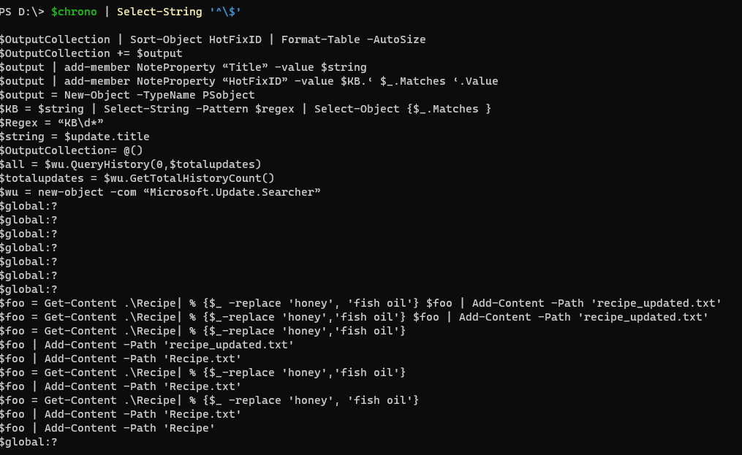

It appears everything is related to foo or recipe. Let’s search for that.

Darn ParameterBindings! Let’s get rid of them as Eric did.

The elf’s diary is fun to read, but we do not need it. Here is the list of commands we need, from the last part of the output.

cat .\Recipe

$foo = Get-Content .\Recipe| % {$_ -replace 'honey', 'fish oil'} $foo | Add-Content -Path 'recipe_updated.txt'

cat .\recipe_updated.txt

$foo = Get-Content .\Recipe| % {$_-replace 'honey','fish oil'} $foo | Add-Content -Path 'recipe_updated.txt'

cat .\recipe_updated.txt

$foo = Get-Content .\Recipe| % {$_-replace 'honey','fish oil'}

$foo | Add-Content -Path 'recipe_updated.txt'

cat .\recipe_updated.txt

$foo | Add-Content -Path 'Recipe.txt'

cat .\Recipe

$foo = Get-Content .\Recipe| % {$_-replace 'honey','fish oil'}

$foo | Add-Content -Path 'Recipe.txt'

cat .\Recipe

$foo = Get-Content .\Recipe| % {$_ -replace 'honey', 'fish oil'}

$foo | Add-Content -Path 'Recipe.txt'

$foo | Add-Content -Path 'Recipe'

cat .\Recipe

del .\Recipe.txt

del .\recipe_updated.txt

#### Linux

You can solve the challenge directly in the terminal if you like Linux.

When you grep 4104, you get hits, and they all have 12/24/2022 as the date. Remember that.

There are no commands though. I examined the fille in less and found that the line after the hit had the command in it. So, let’s also output the line after the hit.  
grep -A 1 4104 powershell.evtx.log | head -n 15  
Ah, commands. Get-WMIObject and Get-Process are PowerShell commands.

Let’s look for lines that begin with a $, as Eric did.

There are many instances of foo and recipe; maybe a search for them will give more information. The or feature (|) of grep is only available in the extended version so we use -E. Since recipe and Recipe both appear, make the search case-insensitive with -i.  
grep -A 1 4104 powershell.evtx.log | grep -Ei '\$foo|recipe'

I forgot to reverse the order as Eric did. We can do that with tac (cat spelled backwards.)  
grep -A 1 4104 powershell.evtx.log | grep -Ei '\$foo|recipe'| tac

Now we have the same list of commands that PowerShell gave. I think it was easier in Linux, but I am biased.

#### Answer List

Our intruder, Grinchem most likely, made a lot of errors before he performed the attack correctly. Only the last seven lines really matter. Here are the answers.

Ready to begin? yes

1. What month/day/year did the attack take place? For example, 09/05/2021.

: 12/24/2022

2. An attacker got a secret from a file. What was the original file's name?

: Recipe

3. The contents of the previous file were retrieved, changed, and stored to a variable by the attacker. This was done multiple times. Submit the last full PowerShell line that performed only these actions.

: $foo = Get-Content .\Recipe| % {$_ -replace 'honey', 'fish oil'}

4. After storing the altered file contents into the variable, the attacker used the variable to run a separate command that wrote the modified data to a file. This was done multiple times. Submit the last full PowerShell line that performed only this action.

: $foo | Add-Content -Path 'Recipe'

5. The attacker ran the previous command against a file many times. What is the name of this file?

: Recipe.txt

6. Were any files deleted? (Yes/No)

: Yes

7. Was the original file (from question 2) deleted? (Yes/No)

: No

8. What is the Event ID of the log that shows the actual command line used to delete the file?

: 4104

9. Is the secret ingredient compromised (Yes/No)?

: Yes

10. What is the secret ingredient?

: honey

## Suricata Regatta

The Snort, and now Suricata, rule language has become the default for Intrusion Detection Systems (IDS) and Intrusion Prevention Systems (IPS). Dusty Giftwrap has a hint for you since you solved the Wireshark phish terminal, and Fitzy has something to say as well. This challenge is an extension of the Wireshark phish. You use the same pcap and write Suricata rules to detect that attack.

<https://suricata.readthedocs.io/en/suricata-6.0.0/rules/intro.html>

### Question 1

Fitzy wants you to add rules to his existing suricata.rules file. He wants you to create a rule that alerts on a DNS lookup (i.e., query) for adv.epostoday.uk. To help you get started, he has a rule in suricata.rules that is similar to what you need.  
alert dns $HOME_NET any -> any any (msg:"ET WEB_CLIENT Malicious Chrome Extension Domain Request (stickies .pro in DNS Lookup)"; dns.query; content:"stickies.pro"; nocase; sid:2025218; rev:4;)

The first page in [the suricata document](https://suricata.readthedocs.io/en/suricata-6.0.0/rules/intro.html) is very helpful if you have never done Snort/Suricata rules before; please read it.

Also note that every rule requires a sid with a unique number. That is how suricata keeps track of rules. User rules are traditionally numbered 1,000,000 and up. You do not need the rev unless you want it.

What is the first rule?

### Answer 1

The parts of the answer are:

alert Our action will always be alert in this challenge. Others are block, pass, etc.

dns This calls the parser for the DNS protocol. It will detect DNS by content rather than port number, so the port number can be left at any

$HOME_NET any -> any any This looks for traffic from the addresses listed in $HOME_NET to any IP address and port. Fitzy asked for lookups, or outgoing traffic.

msg Paste in the message Fitzy asked for.

dns.query This [DNS Keyword](https://suricata.readthedocs.io/en/suricata-6.0.0/rules/dns-keywords.html) will decode the [strange compression method](https://cabulous.medium.com/dns-message-how-to-read-query-and-response-message-cfebcb4fe817) that DNS uses to save space, so you can search without considering it.

content Finally, the URI you are looking for.

sid some number that is unique in surricata.rules.

alert dns $HOME_NET any -> any any (msg:"Known bad DNS lookup, possible Dridex infection"; dns.query; content:"adv.epostoday.uk"; nocase; sid:1000000;)

### Question 2

Now Fitzy wants you to alert if there is any traffic to the evil IP address.

*“STINC thanks you for your work with that DNS record! In this PCAP, it points to 192.185.57.242.*

*Develop a Suricata rule that alerts whenever the infected IP address 192.185.57.242 communicates with internal systems over HTTP.*

*When there's a match, the message (msg) should read Investigate suspicious connections, possible Dridex infection”*

Some hints:

1. You need to check traffic in both directions instead of one. There’s a symbol for that.
2. You do not need to check for content, the IP address is enough. You do need a sid, though.
3. Fitzy said to check for HTTP.

### Answer 2

The symbol for bidirectional traffic is <>. There is nothing after msg except for the sid.

alert http 192.185.57.242 any <> $HOME_NET any (msg:"Investigate suspicious connections, possible Dridex infection"; sid:1000001;)

### Question 3

Fitzy has another request. *“We heard that some naughty actors are using TLS certificates with a specific CN. Develop a Suricata rule to match and alert on an SSL certificate for heardbellith.Icanwepeh.nagoya.  
When your rule matches, the message (msg) should read Investigate bad certificates, possible Dridex infection.”*

You will need to use a [TLS keyword](https://suricata.readthedocs.io/en/suricata-6.0.0/rules/tls-keywords.html) to solve this one. In TLS-speak, a CN is a Common Name, often used as the subject. Remember to use the TLS protocol.

### Answer 3

The keyword you need to use is tls.cert_subject. I added a nocase; to make it case insensitive since I was worried about the capital I in the name.

alert tls any any -> any any (msg:"Investigate bad certificates, possible Dridex infection"; tls.cert_subject; content: "heardbellith.Icanwepeh.nagoya"; nocase; sid:1000002;)

### Question 4

Fitzy has one last request for us.

*“OK, one more to rule them all and in the darkness find them. Let's watch for one line from the JavaScript: let byteCharacters = atob. Oh, and that string might be Gzip compressed - I hope that's OK!*

*Just in case they try this again, please alert on that HTTP data with message Suspicious JavaScript function, possible Dridex infection.”*

Do not let the comment about Gzip bother you. If you use the correct keyword, the parser will automatically unzip as needed. Remember that you are looking in the body of the response from the web server.

### Answer 4

This rule also works with the file_data keyword instead of http.response_body.

alert http any any -> any any (msg:"Suspicious JavaScript function, possible Dridex infection"; http.response_body; content:"let byteCharacters = atob"; nocase; sid:1000003;)

# Ring Retrieved

